Name _________________

WE DO Student Response Page
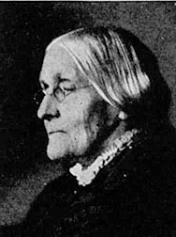

What conclusion can you draw about Susan B. Anthony? Use information from the selection to support your answer.

_____________________________________________________________________________________________________________________________________________________________________________________________________________________________________________________________________________________________________________________________________________________________________________________________________________________________________________________________________________________________________________________________________________________________________

